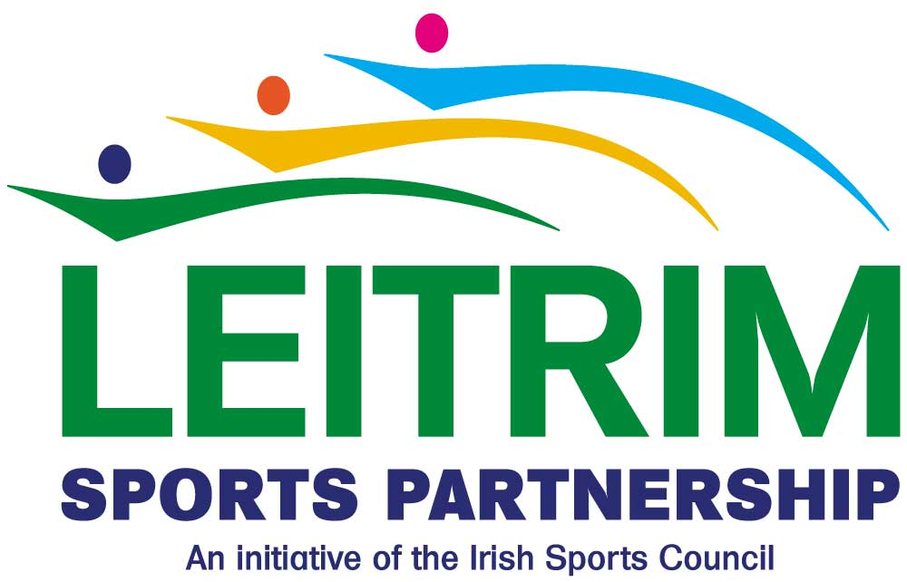

**“Kidz on the Run” Fitness Programme - Expression of Interest Form**

|  |  |
| --- | --- |
| **Name of School:** |  |
| **Address:** |  |
|  |  |
| **Telephone:** |  |
| **Email:** |  |
| **Principal:** |  |

|  |  |  |
| --- | --- | --- |
| **The fitness programme will only be available from Monday to Friday– please indicate which classes you wish to participate on this fitness programme and the number of students.** | | |
| **Class** | **No. of Boys** | **No. of Girls** |
| First Class |  |  |
| Second Class |  |  |
| Third Class |  |  |
| Fourth Class |  |  |
| Fifth Class |  |  |
| Sixth Class |  |  |

**PTO**

**Signature of Principal: Date:**

**Leitrim Sports Partnership**

**C/O Leitrim County Council**

**Áras an Chontae**

**Carrick on Shannon**

**Co. Leitrim**